**A FULL STACK DEVELOPMENT CAPSTONE PROJECT**

FoodBox

*(Source Code)*

* **Version History:**

|  |  |  |
| --- | --- | --- |
| 1. | **Author Name** | B.Uday |
| 2. | **Purpose** | Source Code. |
| 3. | **Date** | 25 April 2023. |

Contents.

1. User Flow Chart Diagram 3
2. GitHub Link… 4
3. Database Design… 4
4. Folder Structure… 6
5. Project Files… 11

# User Flow Chart Diagram.

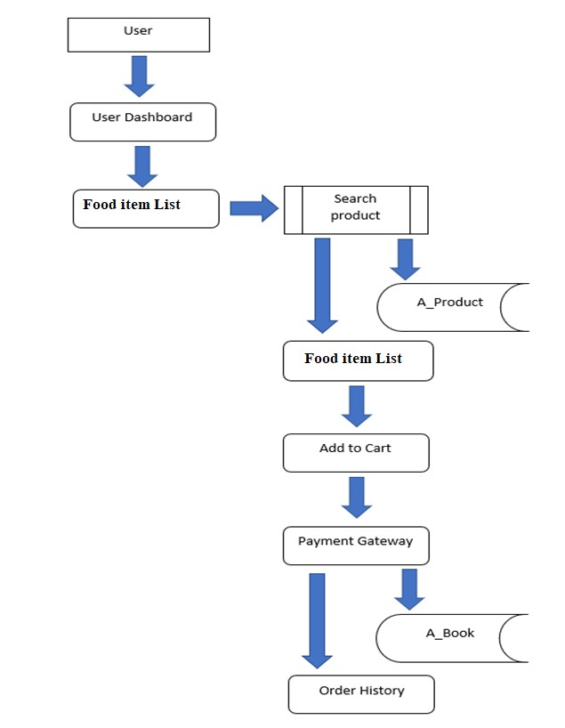

1. ***GitHub Link.***

|  |  |
| --- | --- |
| **Repository Name.** | FoodBox-Capstone-Project |
| **GitHub Link.** | https://github.com/UdayBoppapuram/Foodbox |

1. ***Database Design.***

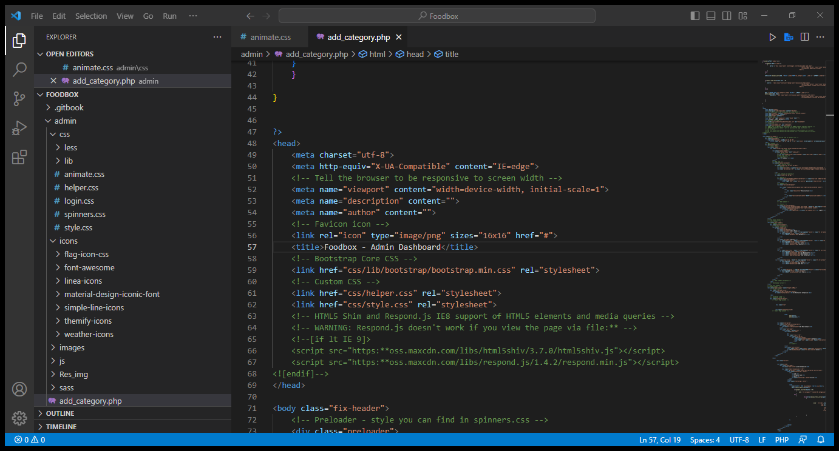

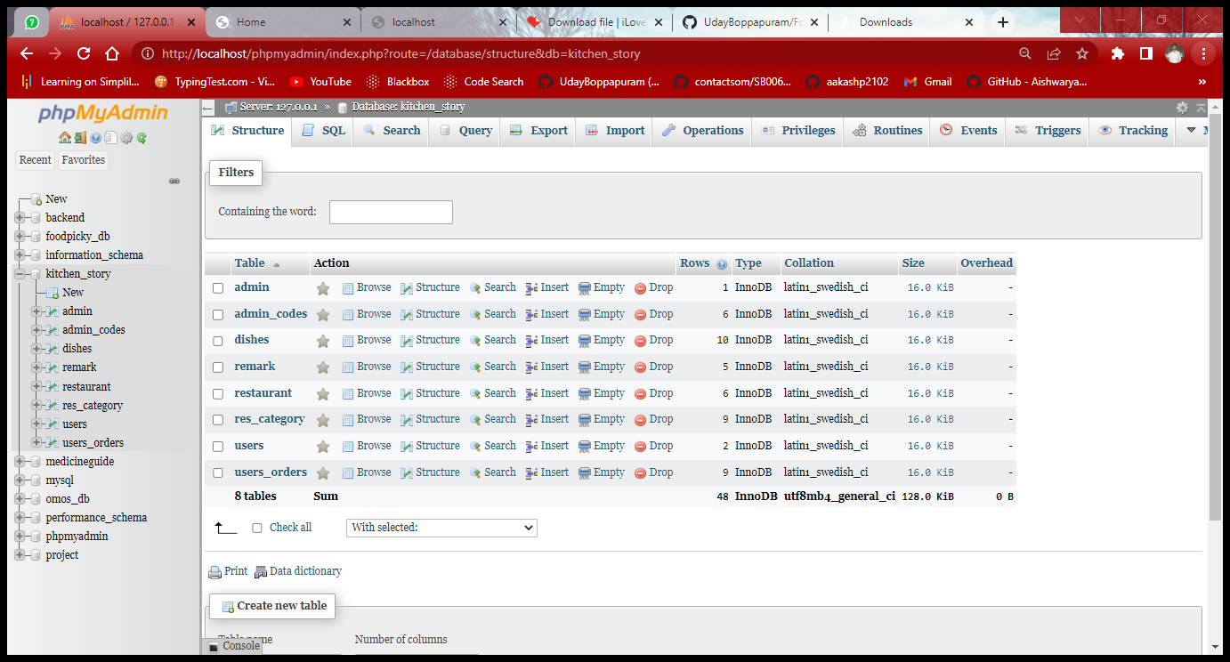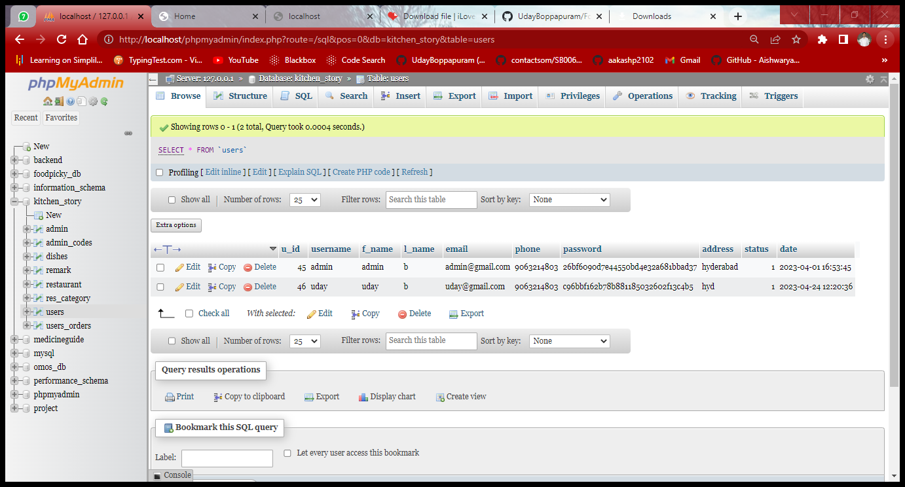

1. ***Folder Structure.***

**(Back End Development)**

Spring Project Structure

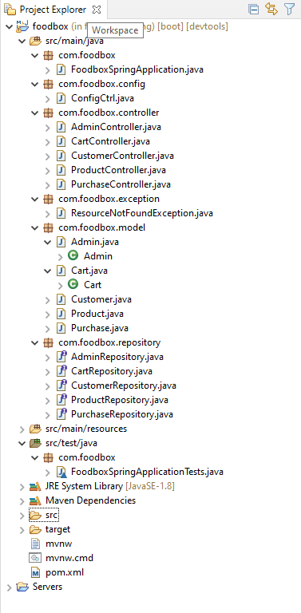

Pom.xml

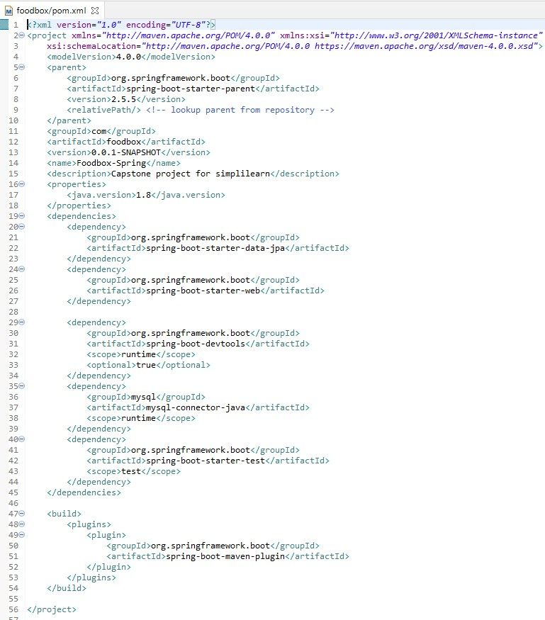

FoodSpringApplication.Java

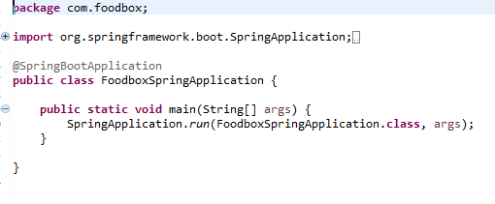

FoodboxSpringApplicationTests.Java

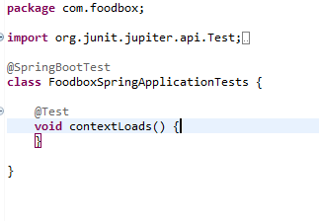

Spring Output:

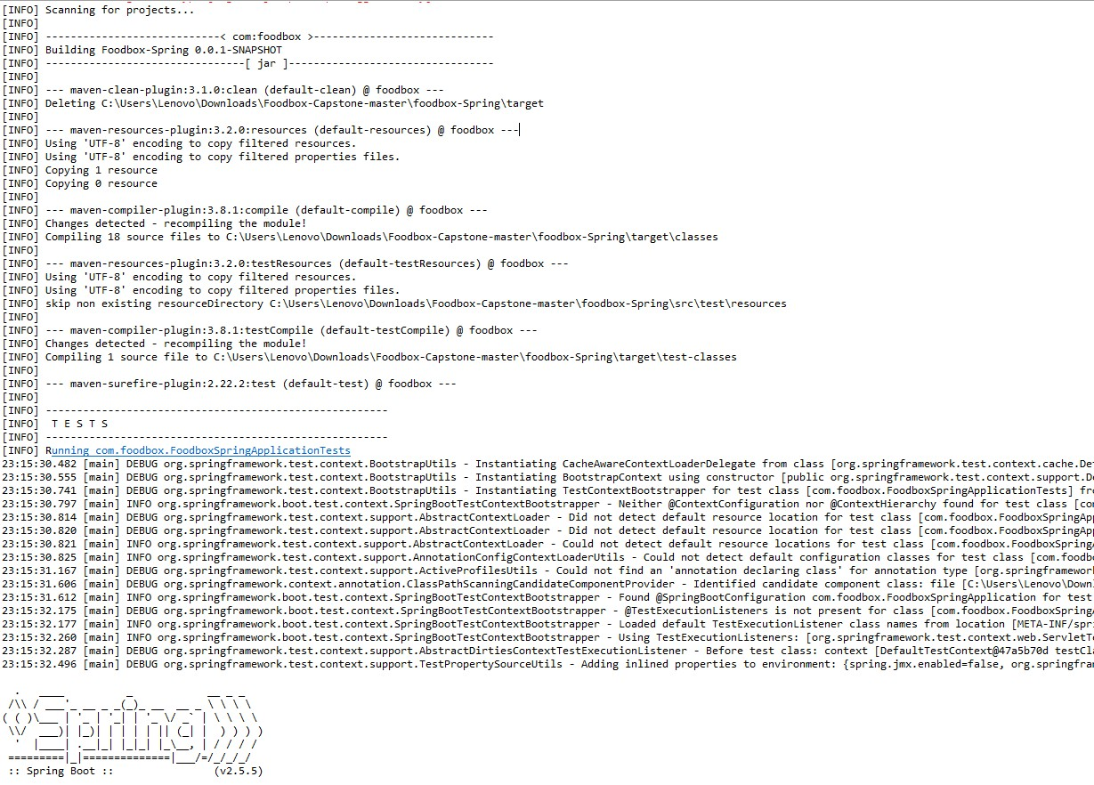

**(Front End Development)**

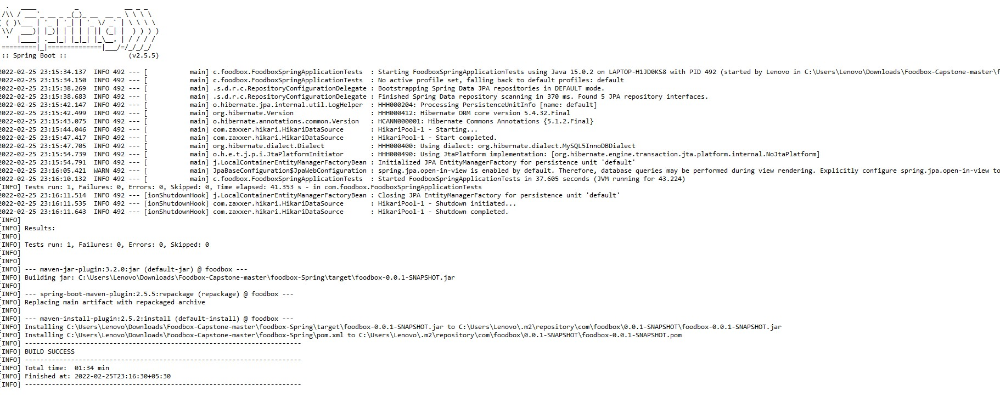

Angular Project Structure:

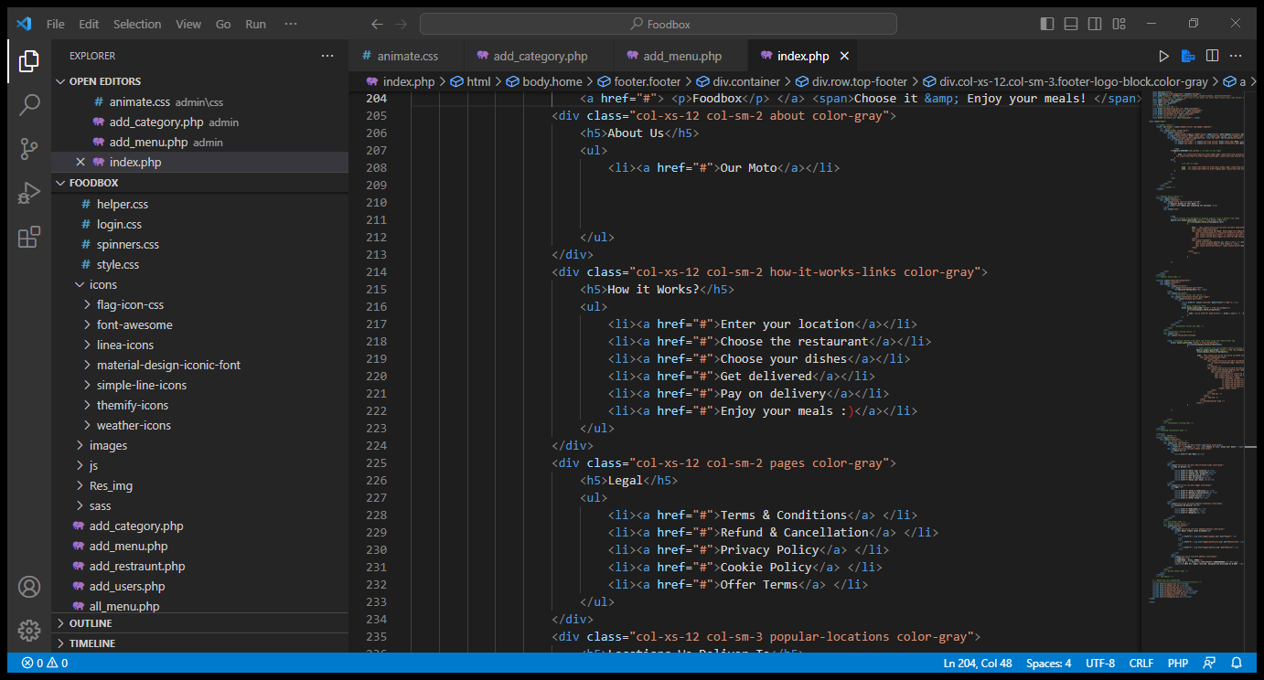

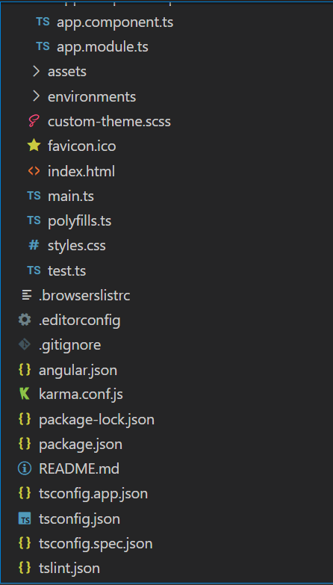

1. ***Project Files.***

Index.html

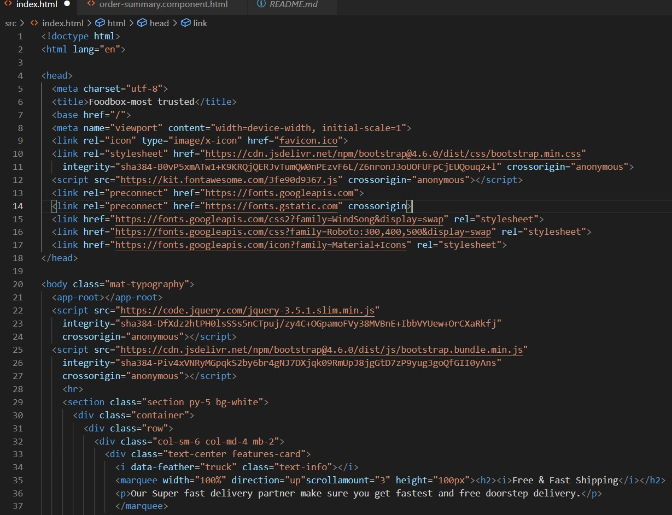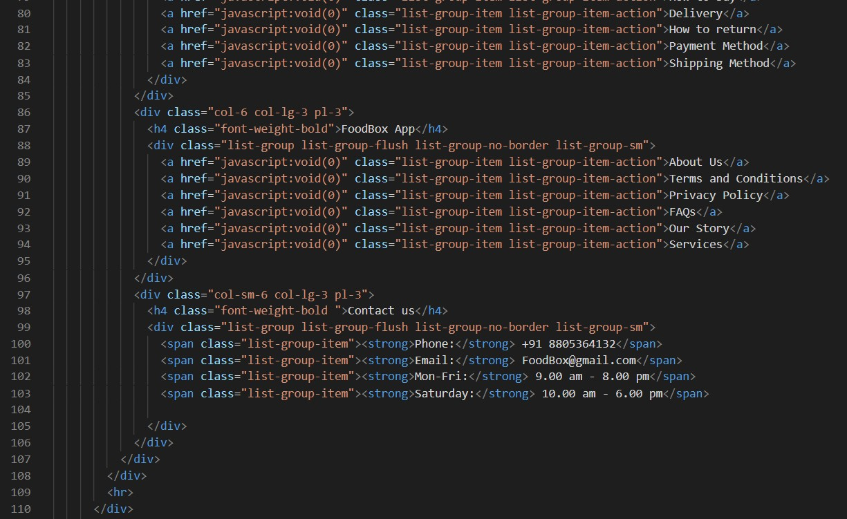

test.ts:

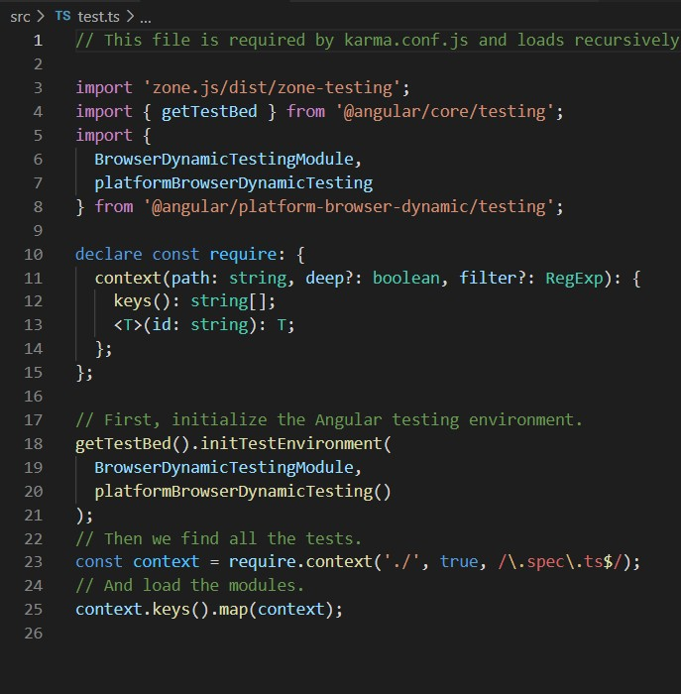

## Package.json:

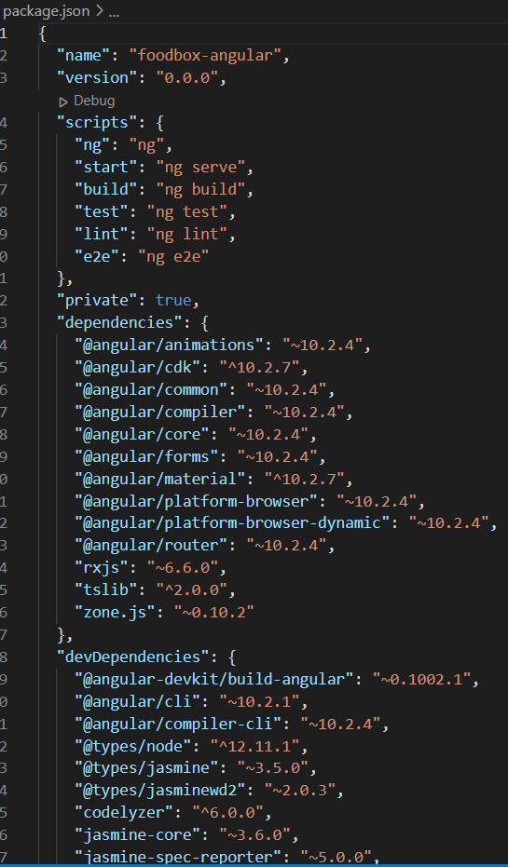

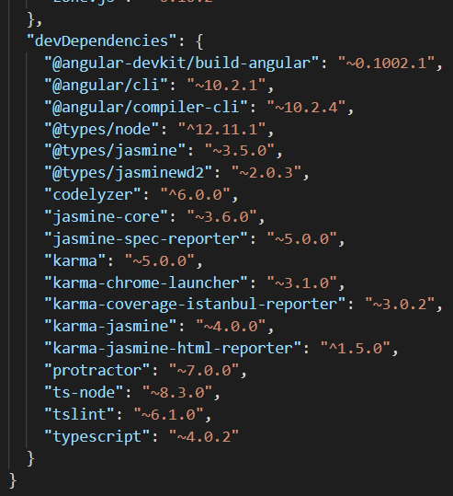

THANK YOU……………